Unit V

GRAPHS

A graph is a collection of vertices or nodes, pairs of which are joined by lines or edges. More formally, a graph G= (V,E) is an ordered pair of finite sets V and E. The elements of V are called vertices( vertices are also called nodes and points). The elements of E are called edges (edges are also called arcs and lines). Each edge in E joins tow different vertices of V and is denoted by the tuple ( i, j) where I and j are the two vertices joined by E.
A graph is generally displayed as a figure in which the vertices are represented by circles and the edges by lines. Some of the edges in this figure are rented, while other are not. An edge with an orientation is a directed edge, while and edge with no orientation is na undirected edge. The undirected edges (i, j) and (j, i) are the same. The directed edge<I, j> is different from the directed edge <j, i> .
A graph need not be a tree but that a tree must be a graph. Also that a node need not have any arcs associated with it.

Vertices i and j are adjacent vertices iff ( i, j) is an edge in the graph. The edge (i, j)is incident on the vertices i and j. Vertices 1 and 2 of Figure (a) are adjacent, as are vertices 1 and 3, 1 and 4 , 2 and 3 , and 3 and 4. This graph has no other pairs of adjacent vertices.
Using set notation , the graphs of above Figure may be specified as
G1 = ( V1, E1), G2 = (V2,E2), G3= (v3, E3)
If all the edges in a graph are undirected, the graph is an undirected graph. The graph of Figures (a) and (b) are undirected graphs. If all the edges are directed, the graph is a directed graph. The graph of Figure (c) is a directed graph.
By definition, a graph does not contain multiple copies of the same edge. Therefore, an undirected graph can have at most one edge between any pair of vertices, and a directed graph can have at most one edge from vertex i to vertex j and one j to i. Also, a graph cannot contain any self-edges; that is edges of the form (i, i) are not permitted, A self-edge is also called a loop.
A directed graph is also called a digraph. In some applications of graphs, we will assign a weight or cost to each edge. When weights have been assigned to edges, we use the terms weighted undirected graph and weighted digraph to reger to the resulting data object.
Application of Graphs:
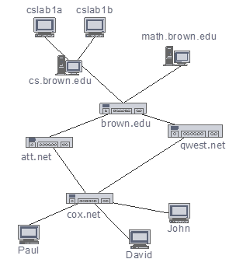
- Electronic circuits
  - Printed circuit board
  - Integrated circuit
- Transportation networks
  - Highway network
  - Flight network
- Computer networks
  - Local area network
  - Internet
  - Web
- Databases
  - Entity-relationship diagram

Graph Terminology:
Degree
Total number of edges connected to a vertex is said to be degree of that vertex.
Indegree
Total number of incoming edges connected to a vertex is said to be indegree of that vertex.
Outdegree
Total number of outgoing edges connected to a vertex is said to be outdegree of that vertex.
Parallel edges or Multiple edges
If there are two undirected edges to have the same end vertices, and for two directed edges to have the same origin and the same destination. Such edges are called parallel edges or multiple edges.
Self-loop
An edge (undirected or directed) is a self-loop if its two endpoints coincide.
Simple Graph
A graph is said to be simple if there are no parallel and self-loop edges.
Path
A path is a sequence of alternating vertices and edges that starts at a vertex and ends at a vertex such that each edge is incident to its predecessor and successor vertex.
Cycle
A path that starts from a vertex and end with the same vertex that path is called cycle. If a graph contains a cycle that graph is called cyclic graph. If a graph with out cycle is called acyclic graph

Graph Representation:
Graph data structure is represented by following representation
- Adjacency List
- Adjacency Matrix
Adjacency List
In this representation, every vertex of graph contains list of its adjacent vertices.
For example, consider the following directed graph representation implemented using linked list...
- Adjacency-list representation of a graph G = ( V, E ) consists of an array ADJ of |V | lists, one for each vertex in V. For each u ∈ V , ADJ [ u ] points to all its adjacent vertices.
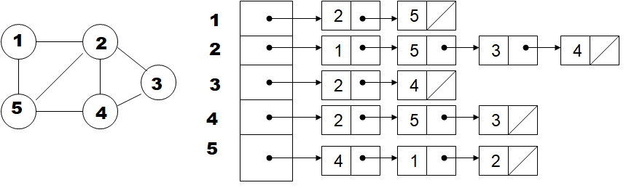

Adjacency-list representation for a directed graph
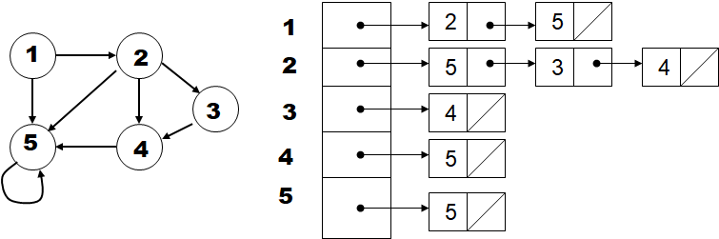

- Advantage:
  - Saves space for sparse graphs. Most graphs are sparse.
  - “Visit” edges that start at v
    - Must traverse linked list of v
    - Size of linked list of v is degree(v)
    - θ(degree(v))
- Disadvantage:
  - Check for existence of an edge (v, u)
    - Must traverse linked list of v
    - Size of linked list of v is degree(v)
    - θ(degree(v))
- Storage
  - We need V pointers to linked lists
  - For a directed graph the number of nodes (or edges) contained (referenced) in all the linked lists is
Σ(out-degree (v)) = | E |.
So we need Θ( V + E )
  - For an undirected graph the number of nodes is
Σ(degree (v)) = 2 | E |
Also Θ( V + E )

Adjacency-matrix-representation of a graph G = ( V, E) is a |V | x |V | matrix A = ( a_{ij} ) such that
a_{ij} = 1 (or some Object) if (i, j ) ∈E and
0 (or null) otherwise.
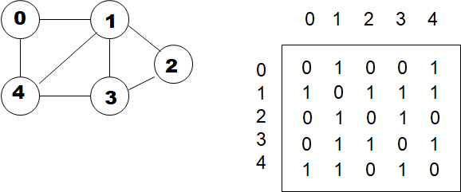

Adjacency Matrix Representation for a Directed Graph
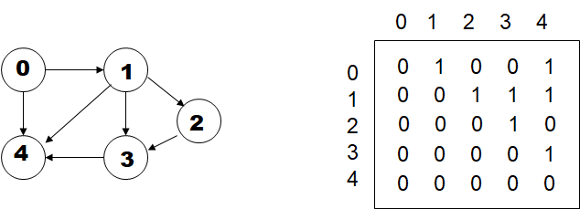

- Advantage:
  - Saves space on pointers for dense graphs, and on
  - small unweighted graphs using 1 bit per edge.
  - Check for existence of an edge (v, u)
    - (adjacency [i] [j]) == true?)
    - So θ(1)
  - Disadvantage:
  - “visit” all the edges that start at v
    - Row v of the matrix must be traversed.
    - So θ(|V|).
Graph Traversals:
Graph traversal is technique used for searching a vertex in a graph. The graph traversal is also used to decide the order of vertices to be visit in the search process. A graph traversal finds the egdes to be used in the search process without creating loops that means using graph traversal we visit all verticces of graph without getting into looping path.
There are two graph traversal techniques and they are as follows...
- DFS (Depth First Search)
- BFS (Breadth First Search)

DFS (Depth First Search)
DFS traversal of a graph, produces a spanning tree as final result. Spanning Tree is a graph without any loops. We use Stack data structure with maximum size of total number of vertices in the graph to implement DFS traversal of a graph.
We use the following steps to implement DFS traversal...
Step 1: Define a Stack of size total number of vertices in the graph.
Step 2: Select any vertex as starting point for traversal. Visit that vertex and push it on to the Stack.
Step 3: Visit any one of the adjacent vertex of the verex which is at top of the stack which is not visited and push it on to the stack.
Step 4: Repeat step 3 until there are no new vertex to be visit from the vertex on top of the stack.
Step 5: When there is no new vertex to be visit then use back tracking and pop one vertex from the stack.
Step 6: Repeat steps 3, 4 and 5 until stack becomes Empty.
Step 7: When stack becomes Empty, then produce final spanning tree by removing unused edges from the graph
Example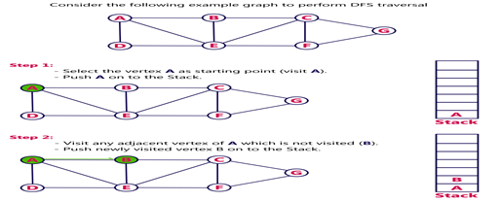

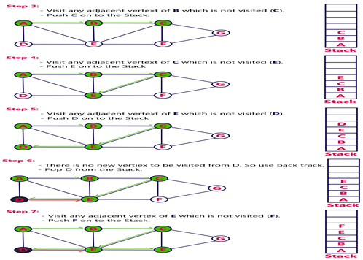

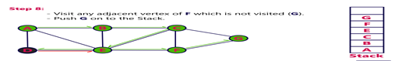
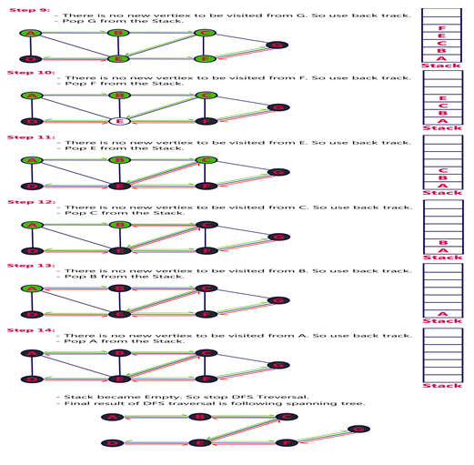

BFS (Breadth First Search)

BFS traversal of a graph, produces a spanning tree as final result. Spanning Tree is a graph without any loops. We use Queue data structure with maximum size of total number of vertices in the graph to implement BFS traversal of a graph.

We use the following steps to implement BFS traversal...

Step 1: Define a Queue of size total number of vertices in the graph.
Step 2: Select any vertex as starting point for traversal. Visit that vertex and insert it into the Queue.
Step 3: Visit all the adjacent vertices of the verex which is at front of the Queue which is not visited and insert them into the Queue.
Step 4: When there is no new vertex to be visit from the vertex at front of the Queue then delete that vertex from the Queue.
Step 5: Repeat step 3 and 4 until queue becomes empty.
Step 6: When queue becomes Empty, then produce final spanning tree by removing unused edges from the graph

External Sorting
External sorting is a term for a class of sorting algorithms that can handle massive amounts of data. External sorting is required when the data being sorted does not fit into the main memory of a computing device (usually RAM) and a slower kind of memory (usually a hard drive) needs to be used.
External mergesort
One example of external sorting is the external mergesort algorithm. For example, for sorting 900 megabytes of data using only 100 megabytes of RAM:
- Read 100 MB of the data in main memory and sort by some conventional method
- Write the sorted data to disk.
- Repeat steps 1 and 2 until all of the data is sorted in 100 MB chunks, which now need to be merged into one single output file.
- Read the first 10 MB of each sorted chunk (call them input buffers) in main memory (90 MB total) and allocate the remaining 10 MB for output buffer.
- Perform a 9-way merging and store the result in the output buffer. If the output buffer is full, write it to the final sorted file. If any of the 9 input buffers gets empty, fill it with the next 10 MB of its associated 100 MB sorted chunk or otherwise mark it as exhausted if there is no more data in the sorted chunk and do not use it for merging.

Heap Sort
- A heap is a complete binary tree
  - That is empty
or
  - Whose root contains a search key greater than or equal to the search key in each of its children, and
  - Whose root has heaps as its subtrees
- Maxheap
  - A heap in which the root contains the item with the largest search key
- Minheap
  - A heap in which the root contains the item with the smallest search key
Heaps: An Array-based Implementation of a Heap
A heap with its array epresentation

Heaps: heapDelete
a) Disjoint heaps
- Step 1: Return the item in the root
  - Results in disjoint heaps

b) a semiheap
- Step 2: Copy the item from the last node into the root
  - Results in a semiheap

- Step 3: Transform the semiheap back into a heap
  - Performed by the recursive algorithm heapRebuild
Recursive calls to heapRebuild
- Step 3: Transform the semiheap back into a heap
  - Performed by the recursive algorithm heapRebuild

- Efficiency
  - heapDelete is O(log n)

Deletion from a heap

Heaps: heapInsert
- Strategy
  - Insert newItem into the bottom of the tree
  - Trickle new item up to appropriate spot in the tree
- Efficiency: O(log n)
- Heap class
Represents an array-based implementation of the ADT heap

Heap Sort
- Heapsort algorithm sorts in place and its running time is O(n log(n)).
  - It combines the better attributes of insertion sort and merge sort algorithms.
  - It is based on a data structure, -- heaps.
- The (binary) heap data structure is an array object that can be viewed as a nearly complete binary tree.
  - An array A that represents a heap is an object with two attributes:
    - length[A], which is the number of elements, and
    - heap-size[A], the number of elements in the heap stored within the array A.
The Worst- case run time of Adjust is also proportional to the height of the tree. Therefore, if there are n elements in a heap, deleting the maximum can done in O(log n) time
Algorithm Adjust(a,i, n)
// The complete binary trees with roots 2i and 2i+1 are comined with node I to form a heap rooted at I, No node has an address greater that n or less than 1
{
j:=2i; item:=a[i];
while( j <= n) do{
if((j<n )and (a[j]<a[j+1]))then
j:=j+1;
if(item>=a[j])then brak;
a[j/2]:=a[j];
j:=2j;
}
A[j/2]:=item
}

The worst-case analysis of Heapiry let 2^{k-1} ≤ n < 2^{k}, where k=log(n+1)
The worst-case number of iterations for Adjust is k-1 for a node on level i. The total time for Heapiry is proportional to
Algorithm Heapify(a,n)
//Readjust the elements in a[1:n] to form a heap
{
for i:=n/2 to 1 step -1 do
Adjust(a,i,n);
}

Algorithm HeapSort(a, n)
//a[1:n] contains n elements to be sorted. HeapSort rearranges them inplace into nondecreasing order
{
Heapify(a,n); //Transform the array into a heap
//Interchange the new maximum with the element at the end of the array
for i:=n to 2 step -1 do{
t:=a[i];
a[i]:=a[1];
a[1]:=t;
Adjust(a,1,i-1);
}
}
Heapify requires only O(n) operations, Adjust Possibly requires O(logn) operations for each invocation. Thus the worst-case time O(n log n).

/* Heap Sort */
void heapsort(int[],int);
void main()
{
int a[50],n,i;
printf("Enter no.of elemets:");
scanf("%d",&n);
printf("Enter elements\n");
for(i=0;i<n;i++)
scanf("%d",&a[i]);

heapsort(a,n);

printf("Sorted array\n");
for(i=0;i<n;i++)
printf("%d ",a[i]);
getch();
}

void heapsort(int x[],int n)
{
int i,ele,s,f,ivalue;
/************ create initial heap ****** */
for(i=1;i<n;i++)
{
ele=x[i];
s=i;
f=(s-1)/2;
while(s>0 && x[f]<ele)
{
x[s]=x[f];
s=f;
f=(s-1)/2;
}
x[s]=ele;
}
/*******************************/
for(i=n-1;i>0;i--)
{
ivalue=x[i];
x[i]=x[0];
f=0;
if(i==1)
s=-1;
else
s=1;
if(i>2 && x[2]>x[1])
s=2;
while(s>=0 && ivalue <x[s])
{
x[f]=x[s];
f=s;
s=2*f+1;
if(s+1<=i-1 && x[s]<x[s+1])
s=s+1;
if(s>i-1)
s=-1;
}
x[f]=ivalue;
}
}

Merge Sort

void merg(int[],int[],int[],int,int,int);
void main()
{
int a[5],b[5],c[10];
int i;
clrscr();
printf("Enter First array values\n");
for(i=0;i<5;i++)
scanf("%d",&a[i]);
printf("Enter second array values\n");
for(i=0;i<5;i++)
scanf("%d",&b[i]);

merg(a,b,c,5,5,10);

printf("Result array\n");
for(i=0;i<10;i++)
printf("%5d",c[i]);
getch();
}
void merg(int a[],int b[],int c[],int alimit,int blimit,int climit)
{
int aindex,bindex,cindex;
if(climit< alimit+blimit)
{
printf("Merg not possible");
return;
}

aindex=bindex=cindex=0;
while(aindex<alimit && bindex<blimit)
{
if(a[aindex]<b[bindex])
c[cindex++]=a[aindex++];
else
c[cindex++]=b[bindex++];
}

while(aindex<alimit)
c[cindex++]=a[aindex++];

while(bindex<blimit)
c[cindex++]=b[bindex++];
}

